17.Create a web page to prepare the mark list to display the marks scored by the students in their class test by using HTML table property.
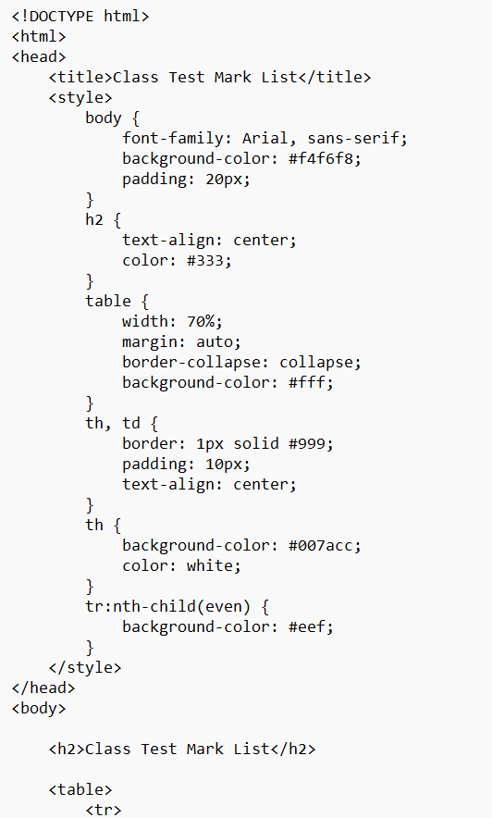
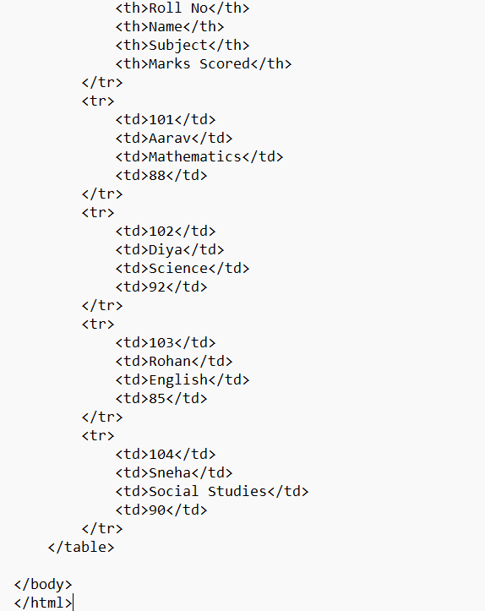
output
